

**Summer Training**

* To study the market for mayonnaise in the Ghaziabad region and to do a market analysis that would help the company in a plan to sell mayonnaise under their brand name.

**Pradyuman Bansal**

**Enrollment no. - A6018216119**

**B.A. (Hon) - Economics**

**(Semester 5)**

|  |  |
| --- | --- |
| Project Guide | Faculty Guide |
| Vishal Singhal | Ms. Manisha Raj |
|  |  |

**INDEX**

|  |  |
| --- | --- |
| Pg no. | TOPIC |
| 3. | Acknowledgement |
| 4. | Study Objective |
| 5. | Introduction |
| 6. | Company Profile |
| 8. | Industry Profile |
| 10. | Methodology |
| 12. | Market Analysis |
| 17. | Findings and Conclusion |
| 19. | Questionnaire |

**Acknowledgement**

I am using this opportunity to express my gratitude to everyone who has supported me throughout the course of B.A. (Hon)-Economics. I am thankful for their aspiring guidance, invaluably constructive criticism and friendly advice during the project work. I am sincerely grateful to them for sharing their truthful and illuminating views on a number of issues related to the project.

I express my warm thanks to **Mr. Vishal Singhal** (My Project Guide) for his constant support, who helped me in collecting the required data as well as designing the suitable Questionnaire.

I am thankful to **Ms. Manisha Raj**, who guided me and provided the necessary theoretical and practical knowledge, which helped me complete, this project. She has been a strong guide in helping me finalize that I should do a project in the company that I am currently working in however new it may be.

Last but not the least, all my friends and batch mates at IMTCDL who provided enormous amount of support and shared the experiences of their project.

Thank you,

Pradyuman Bansal

Enrollment no- A6018216119

**Study Objective**

The objective was to perform a market analysis of the market of mayonnaise in Ghaziabad that includes the following:

1. Market Potential
2. Major players
3. Major Competitors

In addition, for the collection of raw data I needed to find out the purchase prices and the selling prices of the competitive products and perform a basic quality research on the major competitors, also I need to find out the rough estimate of the total sales of mayonnaise.

**Introduction**

The company **SUPER FOODS** is a small unit under the umbrella of Vikrant Group.

Vikrant Group laid its foundation in the year 1990, when the founding firm **Vikrant**

**Ispat Udyog** was established. The company was established with a motive toleverage the experience Mr. Parmod Singhal was gained during his brief stint in an extended family business in Ludhiana of steel trading. The business was started with a minor amount of 2 lakh rupees after massive losses in the steel rolling mill. The business currently has an annual turnover of 500 crores with more than 10 products in its distribution portfolio.

From there on, the business has ventured into a number of Industries ranging from Bone China, Hand Pump Parts to Food Processing proving their mettle in each industry they enter into.

This report is regarding one of such Units, Super Foods where Vegetable Fat Spread & Margarine is manufactured under its own brand name ‘**EatLite**’. This company has grown itself to an annual turnover of 3 crores in the past 1.5 years. The company currently has a distribution network of 12 dealers and 3 super stockist.

With the costing of the product increasing with increasing distance from Gujarat there is limited potential in selling a single product. The product thus can only be sold in Northern India at a Competitive price. Thus there is a rapid need to expand our product portfolio not just leverage the current reseller network but also increase the network based on other products, such as Mayonnaise, etc.

The key to selling a food product in a retail market is the branding activities that accomplishes. Establishing ‘EatLite’ as a brand can definitely help us in mitigating the location barrier in the long term.

Thus we need to have a clear focus on all the ATL and BTL activities that can be carried out a cheap cost with maximum impact. The Director of Finance and Operations of this company is a B. Tech. in biotechnology from Delhi College of Engineering. He has a vast knowledge in terms of food processing and the various ingredients that can be utilized to make the product at a cheaper price without compromising the quality. The Director, Sales & Marketing is a BBA in International Business from Amity University UP, has also done Business Administration from California State University, San Bernardino and Birkbeck, University of London. He has the required skill set to drive sales and marketing related activities.

**Company Profile**

In the year 2015 we had ventured into manufacturing of Vegetable Fat Spread under our own brand name “EatLite”. The plant was commissioned in August 2016. And the product was launched in the market with the first distributor established in the Ghaziabad Area itself. Currently, EatLite has strong presence in the market of Western UP, Uttrakhand, Punjab, Haryana and Delhi. There are close to 12 distributors and 3 Super Stockists through which the material is sold to the institutions and end customers.

The plant for manufacturing Vegetable Fat Spread in located in a village near the town of Pilakhuwa. It is a 30000 sq. feet facility having a covered area of 10000 sq. feet. We have a plant having a daily capacity of 10 tons in terms of production. Currently the packing machine that we own can only pack 6 tons in a day. There are a couple of packing formats available in the markets that don’t require this specific 100-gram packing machine. The facility has enough space to double the production capacity if need be. There is a strict maintenance of proper hygiene conditions in order to make sure that the product we manufacture is of the best quality. The facility is licensed by FSSAI for manufacturing of the same. We are under the process of acquiring Agmark License and GMP certificate for our facility as well.

**Mission:**

Super Foods strives to satisfy the taste and nutrition requirements of the customers, through excellence in marketing by their committed team and supply chain network.Through innovative product development, we are committed to offer quality products that provide best value for money.

The mission for the company is as follows: -

**Provide quality foods and beverages to consumers at affordable prices while providing satisfaction to the customers, employees and distributors.**

**Vision:**

Super Foods has had a massive growth since its launch with attaining an annual turnover of 3 crores in 1.5 years. Being in its growth phase, it is expected to attain a massive growth trajectory having increment in sales by 5% every month. Hence, following is our vision for the next 5 years.

**Our vision is to achieve an annual turnover of 50 crores with a product portfolio containing at least 10 SKUs till 2022.**

**Products Range:**

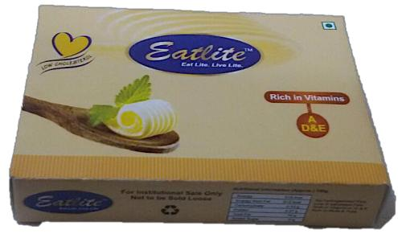

Currently we are into manufacturing of a single product in two different packing formats. The product is called Vegetable Fat Spread. It is available in single 100gram x150 = 15 kg carton and (100x5) x 32 = 16kg carton packing. The cartons are of exact same dimensions.

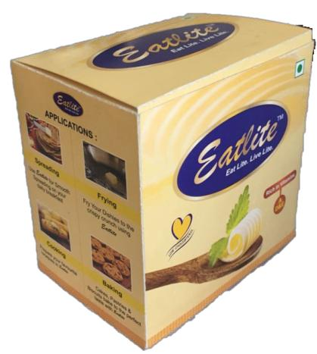

**Industry Profile**

The Indian food and grocery market is the world’s sixth largest, with retail contributing 70 per cent of the sales. The Indian food processing industry accounts for 32 per cent of the country’s total food market, one of the largest industries in India and is ranked fifth in terms of production, consumption, export and expected growth. It contributes around 8.80 and 8.39 per cent of Gross Value Added (GVA) in Manufacturing and Agriculture respectively, 13 per cent of India’s exports and six per cent of total industrial investment. The Indian gourmet food market is currently valued at US$ 1.3 billion and is growing at a Compound Annual Growth Rate (CAGR) of 20 per cent. India's organic food market is expected to increase by three times by 2020.

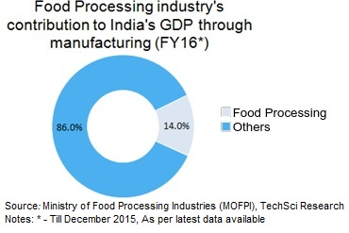

The increase in spending capacities & the concurrent time-paucity has led to the continuous development of such frozen processed food products as frozen vegetables (e.g. peas, potato, corn, etc.) and non-vegetarian products such as chicken, fish & meat products. Food processing market accounts for 32 per cent of the total food market in India.

Now, coming on to the Vegetable Fat Spread specifically, **Zydus Cadilla** first established the margarine industry/ market segment in India by launching their brand of **Nutralite** in the year 2006. They were able to create a perception in the mind of the customer that Vegetable Fat Spread is a healthier alternative to butter. They were able to market the product in a way that the end consumers started to purchase the product instead of butter. They were able to show the true benefits of the product i.e. being cholesterol free, MUFA/PUFA rich, low fat etc. The cost price of Vegetable Fat Spread is one-fourth to that of Milk Fat based Butter. This economic factor was the key reason that other local brands were able to drive their sales on in the market. Nowadays, this product is used by most of the institutions in the Hotels, Restaurants, Caterer segment because of the cheap price and same taste/flavor as that of butter.

Currently the center of manufacturing of Vegetable Fat Spread is Gujarat. The main raw material i.e. Refined Palm Oil (RPO) is imported in the crude form at the Kandla port in Gujarat where it is refined and then used by the food processors to create fat spread. Most of the big brands, Nutralite, Nutdelight, Delicious, VimalLite are manufactured in Gujarat only. The industry has been widely commoditized with the product being sold at wafer thin margins to these institutional customers. The costing of the product manufactured in Delhi and sold in Delhi is more expensive than the one being brought from Gujarat. Hence, there has been great competition across brands in the market.

There are only two brands which are currently being sold at modern trade outlets i.e. Delicious, Nutralite.

The industry has been growing exponentially since past 7 years with more than 15 brands established in last 4 years in the market. The Northern Indian market has grown at approximately 25% per annum.

There are a lot of products that act as potential substitutes for Fat Spread especially in the institution sector. One such new product that has been launched by **Tapan Group** based out of Agra is a **Vegetable Oil based cooking medium**. A HoReCa customer for making dishes such as Pav Bhaji, etc. commonly uses this product.

**Methodology**

I was given the project to do a research on the marketing potential of ‘Mayonnaise’ (a product that the company is willing to bring in the market under its brand name) in Ghaziabad.)

I started off by understanding the nature of product, what it is, where it is used, etc.

After that, I concluded that the research actually requires two major things for each segment:

* The major players in the segment
* The major competitors in the market

Then I started looking for the various associations and statistical sites that keep this kind of data.

I found out that there are very few statistical sites that provide data for free; they either ask you for subscription or for a fee.

Now, since I was told that getting a subscription approved may take a long time, hence I was asked to work with the data available for free.

The brands I picked range from domestic ones priced as low as Rs.70 going up to foreign brands costing Rs.400. And within this wide range I managed to include most of the popular brands available in the Indian market:

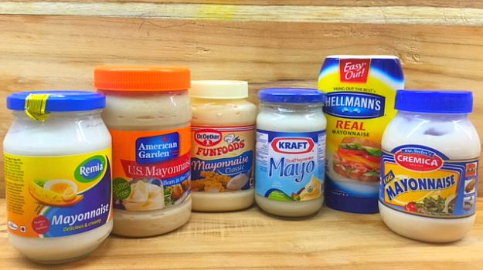

-Cremica

-Fun Foods

-Kraft

-Hellmans

-Remia

-Veeba

Dr Oetker

By researching, I also found out that all these brands used different types packaging that had different prices for eg:

* 1 Kg packaging that was the most common with the consumers.
* The bottled packaging that also came in various quantities.

The entire data till now was of the major competitors in the market.

My work ahead was to estimate their net sales in the area of Ghaziabad and then to understand the Major Players in the market (Consumers).

For the further knowledge and data I had to go for a field work that is elaborated in the market analysis section of my report.

**Market Analysis**

**Understanding the major players, the Competition and the consumption:**

The major players that I targeted were the following:

* Restaurants
* Fast food joints
* Hotels

I understood that these are the market players that consume mayonnaise in bulk and so they were the target of my study.

Understanding the consumption was again a very important part of my research as it will allow the company to decide weather or now it is ‘economically viable’ to enter the market.

After that I went to all these places individually to collect the raw data and talked to the managers personally about their usage of mayonnaise.

By this survey I found out that most of these consumers are buying the boxes of 1g packaging as it is cheaper than the bottles packaging. Of course the reputed and A rated hotels and restaurants were using a good quality mayonnaise like Veeba or Fun foods or Cremica and the other local venders and fast food joints were using a cheaper brand.

I majorly focused on the particular brands as SUPER FOODS is a company that is known for its good quality of products. Those were:

* Veeba
* Cremica
* Fun Foods
* Dr Oetker

I found out that these are the only brands that are mostly being used by the major players.

So at the end of my survey I found out the following data:

I also wanted to find out the uses of mayonnaise i.e. the different types on consumption of mayonnaise.

Now that I got a rough idea of the sales of our competitors in Ghaziabad I compiled a data of the different prices are which they are sold to these consumers that is often referred to as the landing style.

Before that I wanted to understand the **supply chain** which was very easy to understand as I have gained knowledge by working with the company. So here’s the supply chain that I understood

So as we can see from the chart I formed above, the supply chain is as follows. The manufactured product from the manufacturer is supplied to the different distributers in different areas. No more than one distributer is present in the same area (so that there are no disputes). And then these distributers sell the product to the different consumes in their region.

**Understanding the Prices:**

Since I have been focusing on the four major brands I will only talk about the prices of those. In my research I needed to find out the landing prices i.e. the prices at which the consumers buys the product from the distributer in bulk and the prices at which the distributers gets it from the manufacturers.

|  |  |  |
| --- | --- | --- |
| **Brand** | **Distributer landing price (1 catroon = 12kg) i.e. 12 packets (Rupees)** | **Consumer landing price**  **(12 cartoon = 12kg) i.e. 12 packets (Rupees)** |
| 1.Veeba | 840- 900/- | 1150- 1250/- |
| 2.Cremica | 800- 900/- | 1100- 1200/- |
| 3.Fun n Foods | 900-950/- | 1200-1300/- |
| 4.Dr. Oetker | 900-1000/- | 1200-1300/- |

I only focused on the 1kg packaging because it was told to me by my seniors that if they decide to enter the market, they’ll do it with the 1kg packaging only, moreover as I mentioned earlier, mostly the consumers that we are targeting are using the 1kg packaging.

This was the major part of my research as it helps the company at what price the product can be brought into the market under their brand name.

Now I needed to the consumption of the major players who use the maximum amount as compared to the others. The list of these names was given to me by my seniors.

The lists of the names are:

|  |  |
| --- | --- |
| **List of names of the major Players (with the brands they use)** | |
| **Fast Food joints** | **Hotels and Restaurants** |
| Yours Pizza – Veeba and Cremica   * 4 cartoons/ day | Cinch – Dr. Oetker   * 2 boxes/ day |
| Sandwedges – Veeba   * 3-4 cartoons/ day | Fortune Hotel – Dr. Oetker or Fun n Foods   * 10 boxes/ day |
| Celebrity Kitchen – Fun n foods   * 5 boxes/ day | Handi Highway Dining – Veeba   * 5-6 Boxes/ day |
| Zaika – Veeba   * 4-5 boxes/ day | Vintage Café- Cremica   * 2-3 boxes/ day |
| Hungers Strike – Dr. Oaetker or Fun n foods   * 2-3 boxes/ day | Shanghai Restaurant – Cremica   * 3-4 boxes/ day |
| Snac O’ Bite – Cremica   * 3-4 boxes/ day | The food workshop – Dr. Oetker   * 2-3 boxes/ day |
| Om Sweets – Kraft or Fun n Foods   * 5-6 boxes/ day | Garden Grill – Fun n Foods or Cremica.   * 4-5 Boxes/ Day |

**Building the Trust of the consumers:**

One of the main reasons that a consumer prefers a particular brand is that the consumer has a trust towards the brand, its Quality, its Prices, etc.

So the next part of my job was to build the trust of the consumers so that they can happily use our product after it is launched in the market.

Building the trust becomes a difficult job when you don’t have your product ready yet. So I asked my seniors about this and they gave me a rather easy solution. They told me when I go on the field work, I should carry on some 100g packs of their Eatlite fat spread (butter) and give it to the consumers as ‘free samples’ and ask them to use this in one of their dishes so that they can trust the quality of the product and I did the exact same thing and in return I got back several positive responses by the consumers.

This helped in 2 ways:

1. Trust was established towards our Brand among the consumers about the quality of our product.
2. Many of those consumers who were earlier using some other fat spread shifted to Eatlite that increased the overall company sales marginally.

**Findings and Conclusions**

**Findings:**

* I not at all suspected that there would be such a big market for mayonnaise in Ghaziabad, the survey I did helped me in knowing the market.
* I got a fair idea of the market of mayonnaise in Ghaziabad area.
* Mostly consumers now days want to use good quality products instead of cheap quality ones.
* Still many people are there in some areas og Ghaziabad like Modi Nagar and Nandhgram who don’t even know about mayonnaise.
* The consumers now are days are not hesitant on experimenting with new products. Big consumer chains such as Dominoes and Pizza Hut are also experimenting with different products.
* Mayonnaise is available in many different flavors in the market and also has an option for eggless mayonnaise.
* Most of the fast foods stall and restaurants, they use the simple mayonnaise that is not some special flavored and that is eggless so therefore I did not include the data for flavored and other different types of mayonnaise in my report as it would be of no interest to my company.
* We all think that the restaurants and other fast food joints are very secretive about the products they use, but I didn’t saw this in my research. Even the big players such as dominoes and pizza hut, they can tell you what brand products they are using.

**Conclusions:**

* Based on my research and all the data that I have compiled using the internet and doing the field work mostly, I feel that there is a great scope for the company if it enters the market of mayonnaise.

I say so because since the company had already established many distribution chains in Ghaziabad and all over India so it would not be a very difficult task in searching of new consumers as the consumers have already been established because of the already functioning butter chain. I saw that the restaurants, hotels and etc consumers that are present in our distribution network must also be using mayonnaise in some way or the other, or else they will have the knowledge of the other consumers that use mayonnaise in their products so it will not be a difficult task for the company to establish a distribution network for mayonnaise as well.

And looking at the facts and figures of my report I must say that there is a rather strong market for mayonnaise out there that will boost up the company sales and its turnover. Moreover, it is always good to diversify your business. The more you diversify the more your brand name will be known to the people and the more trust will be established towards the brand. So entering the market of mayonnaise is a good idea for the diversification of the company and I believe it will surely increase the profits of the company.

* Lastly I would like to mention that I really enjoyed my summer break doing this project. I thank Mr. Vishal Singhal, the owner of the startup to provide me with this work and it’s been an honor working for him and his company.

I really like the idea of the startup and I wish to initiate a startup of my own and then building it into a big company. It really was a great experience for me and I gained a lot of inspiration working with SUPER FOODS.

**Questionnaire**

**1. Name (with designation): ___________________________________________**

**2. Name of the hotel, restaurant or food stalls:**

**3. Address: _________________________________________________**

**4. Contact. No. _____________________________________________**

**5. What brand of mayonnaise are you currently using?_____________________________________________________**

**6. Are you satisfied with the product you are using? __________________________________________________________**

**7. What is the landing price? __________________________________**

**8. Where are you buying from? ________________________________**

**9. How much quantity is being used roughly? ____________________**

**10. Would you like to try our product whenever we launch it in the market? __________________________________________________**

**11. Any more Questions? ____________________________________________________________________________________________________________________**